Rick Marshall
Director of Safety - ADSC
Abstract
The ADSC - The International Association of Foundation Drilling in association with the NCCCO is proud to bring you this reference manual to assist you in your preparation for the NCCCO Foundation Drill Rig Operator Certification Exam.
Special thanks go to the members of the NCCCO Foundation Drill Rig Task Force for their cooperation in the development of this resource.
Large Foundation drill Rig
Reference Manual


Table of Contents
Introduction 5
Definitions 7
Project Planning 8
General 8
Training of Employees 8
Site Management 8
Safety Management 9
Foundation Technique Selection 9
Design of Working Platforms 10
Communication 11
General Requirements for Foundation Drill Rigs 12
Operator Training Requirements 12
Intended Use of the Foundation Drill Rig 12
Ergonomics 12
Hot & Cold Surfaces and Sharp Edges 12
Ventilating Ports 12
Hoses, Pipes and Fittings Under Pressure 12
Handling of the Drill Rig and Its Parts 13
Access to Operating Positions and Servicing Points 14
Isolation of Energy Sources 14
Driving, Tramming and Operating Position 14
Operator’s Position 15
Controls, Functions, Systems 16
Starting 16
Stopping 16
Normal Stopping 16
Emergency Stops 16
Failure of the Power Supply 17
Failure in a Control Circuit 17
Control Devices 18
General 18
Stability 20
General Stability Criteria 20
Dynamic Forces 21
Wind Force 21
Other Working Forces 21
Operating Conditions 22
System for the Measurement of Inclination 23
Stability of Truck and Trailer Mounted Drill Rigs 24
General 24
Drill Rig Brakes 25
Wheel Mounted Brakes General 25
General Braking Requirements for Wheel Mounted Drill Rigs 25
Service Braking System for Wheel Mounted Drill Rigs 26
Secondary Braking System for Wheel Mounted Drill Rigs 26
Inspections and Maintenance – Highway Travel 26
Parking Braking System for Wheel and Crawler Mounted Drill Rigs 27
Service Braking Systems on Crawler Mounted Drill Rigs 27
Braking Systems for "Skid Steer" Wheel Mounted Drill Rigs 28
Protection Against Moving Parts 29
General 29
Transmission Parts 29
Drill Rigs with Rotating Superstructure 29
Electric Power Installation 30
Battery Installation 30
Hydraulic Systems 30
Draw-Works, Winches and Ropes 32
General 32
Safety Requirements 33
Inspection 34
Warning Devices 35
Set-up and Operation 36
Location 36
Locating Underground Utilities 36
Equipment 37
Loading – Unloading Equipment 38
Assembly and Disassembly of Rigs 38
Exclusion Zones 39
Powerlines and Electrical Equipment 40
Overhead Powerline Safe Working Clearance: 40
Equipment, Inspection and Maintenance 41
General 41
Pre-operational Inspections 41
Routine Maintenance 42
Annual Inspections 43
Competent Person for Inspections 43
Repairs 43
Welding 43
Equipment Modifications 44
Maintenance Records 44
Drilling Operations 45
General 45
Auxiliary Winch for Lifting 46
CFA Drilling 48
Acknowledgments: 49
Appendices: 50
Resource Material Available Without Cost: 66
Overhead Powerline Safe Working Clearance: 66
Underground Utility Location: 66
Rotary Foundation Drilling Rig Safety: 66
Construction Safety Regulations: 67
OSHA – Occupational Safety & Health Administration 67
US Army Corps of Engineers Safety and Health Requirements Manual 67
The Federation of Piling Specialists 67
The National Institute for Occupational Safety and Health (NIOSH) 67
Canadian Centre for Occupational Health and Safety – Links to Provincial Requirements 67
Canada National Occupational Health and Safety Regulations 67
Education: 67
Northern Alberta Institute of Technology (NAIT) Foundation Drill Rig Operator Program 67
Rigging Information: 67
Crosby Group 67
National Commission for the Certification of Crane Operators (NCCCO) Reference Manuals 67
Resource Material Available for Purchase: 68
European Standards: 68
EN 16228-1 Drilling and Foundation Equipment - Safety - Part 1 – Part 7 68
American Society of Safety Professionals (ASSP): 68
ANSI/ASSE A10.23-2014 - Safety Requirements for the Installation of Drilled Shafts 68
ADSC: The International Association of Foundation Drilling: 68

Introduction

The term “Foundation Drill Rig” covers several differing types of machines for use in the deep foundation construction industry. This guide is intended to cover those drill rigs used in the excavation of drilled shafts, caissons, drilled piers, cast-in-drilled-hole piles (CIDH piles) or Cast-in-Situ piles, and addresses many of the most common hazards associated with mechanized drill rigs when they are used as intended by the manufacturer.

See the following examples:

Definitions

Danger/Exclusion Zone: any area within and/or around a drill rig in which a person is exposed to risk of injury or damage to health. For a drill rig, this means the area in which a person can be reached by movement or the drill rig, its working devices, its auxiliary equipment or swinging or falling material.

Working Area: an area near a drill rig where its tools and or material are moved to carry out the installation of a drilled deep foundation element.

Exposed Person: a person who is wholly or partially in the danger zone

Operator: a person operating the drill rig. They may also be the driver of the rig if it is a carrier mounted rig.

Stability Angle: the angle between the vertical plane, passing through the tipping line and the plane passing through the center of gravity, and the tipping line. The stability angle thus defines the tilt angle to overturning.

Tramming: traveling of a crawler mount drill rig on site.

Safety factor of rope: the ratio between the minimum breaking load of a rope by the manufacturer, and the maximum pulling force of a rope on the first layer of a winch.

Project Planning

General
Planning and preparation should be done early in the development of each project and include consultation with relevant participants such as the Owner, General Contractor (GC), the Deep Foundation Contractor (DFC), along with overhead and underground utility authorities, geotechnical consultants, structural engineering consultants, and other relevant subcontractors. The deep foundation project should be considered in its entirety, when considering how to control risks and how many employees to engage.

Training of Employees
Employees of the Deep Foundation Contractor (DFC) must be informed and aware of Occupational Health and Safety matters that directly affect them. This includes identifying hazards and risks and determining risk controls. Employers should involve all employees in the development of safe work procedures such as hazard identification, risk assessment and risk control methods.

Site Management
Each employer on a given project needs to effectively manage the safety of their employees, material, and equipment. These duties remain even when they overlap with those of other employers.

For example, if a General Contractor (GC) has a supervisor on-site the Deep Foundation Contractor (DFC) must still supervise their employees to ensure their work is being done safely. Deep Foundation Contractor (DFC) employers should have processes in place to effectively manage the work over which they have management or control, including processes to ensure:

- site-specific safe work practices are developed for other tasks where there is risk to employees or the public
- Job Hazard Analysis are developed for all deep foundation work
- employees are trained and knowledgeable of their assigned tasks and are directly supervised by competent employees
- site conditions are monitored for known and potential risks
- employee health, safety, and welfare is monitored

Safety Management
The Owner and or General Contractor (GC), and Deep Foundation Contractor (DFC) should consult on the deep foundation installation and agree on the responsibilities for managing safety for each activity associated with the work. The Owner / General Contractor (GC) should clearly identify who will be responsible for managing safety for each of these activities and coordinate with the Deep Foundation Contractor (DFC) to ensure the risks are effectively controlled.

Deep Foundation Contractors should develop plans and procedures to manage the works and associated risks, including:

- internal and external vehicle or equipment traffic
- loading/unloading of equipment, cages and piles (designating ‘lay-down’ areas for storage of materials)
- maintenance and operation of the foundation drill rig
- erection and disassembly of the foundation drill rig
- high risk construction work (develop a site-specific safety plan)
- operational safety and exclusion zones around foundation drill rig
- access to and around the site to reposition the foundation drill rig
- foundation drill rig working platform (design, certification and maintenance)
- ground penetrations and pile holes (fall protection)
- falls from height and falling objects
- underground and overhead services (locating, marking, relocating, protecting or isolating) emergency procedures
- the effects of the foundation drill rig working near buildings, structures, or excavations
- movement of foundation drill rig into areas not visible to the operator
- protection of the public.

Deep Foundation Contractors should also consider how many suitably trained workers they need to allocate for each activity.

Foundation Technique Selection
During the planning phase of the project, select the most appropriate foundation technique for the site. When determining the technique consideration should be given to all the site factors, including:

- requirements of the proposed structure and applied loadings
- ground conditions
- environmental factors, such as nuisance to the public, effect on wildlife and their habitat, noise or vibration and waste products (i.e. drill spoil)
- site access, location and size
- proximity to existing assets, such as utilities, roads, railways and sensitive structures
- ground contamination
- water table

A competent person should assess the suitability of a specific foundation drill rig for the job.

Design of Working Platforms
A critical factor in any foundation technique is the surface required to support the foundation drilling rig and ancillary equipment during operation or when moving about the site is a safe working platform. A working platform is defined as the surface at a construction site where deep foundation equipment operates. The working platform is typically constructed from compacted soil, geotextile fabric, crushed rock, crane mats or a combination of each.

Inadequate working platforms can cause foundation drill rigs to become unstable and collapse with catastrophic results, including the potential for multiple deaths or injuries to Deep Foundation Contractor (DFC) employees, other people onsite and members of the public.
The Owner / General Contractor (GC), Deep Foundation Contractor (DFC) and other contractors must ensure the working platform is adequate, as all have legal duties associated with providing a safe workplace. During the planning phase consult and agree on the minimum design requirements for the platform and ensure a competent person (e.g. a geotechnical engineer) designs the working platform.
Example of a poor working platform

A key factor of platform design is the maximum bearing pressure generated by the foundation drill rig or ancillary equipment. The Deep Foundation Contractor (DFC) must provide this information and other relevant equipment specifications to ensure a suitable platform is designed.

Equipment bearing pressure calculations should be based on those experienced during operational activities, rather than weight to track area that can be significantly lower than those experienced during operation.

Provide the operator with a copy of the working platform approval document, prior to the foundation drill rig accessing the platform. The operator should review and keep the approval, so it is readily available throughout works.

Before using another rig, other than the one designed for that platform, verify the rig is suitable for the platform. Due to weight to track area ratios, smaller rigs may have higher bearing pressures than larger rigs.

Ensure no Deep Foundation Contractor (DFC) works occur in areas where other site activities (e.g. trenching) have affected the integrity of the platform. Deep Foundation work can only occur in the affected area when the platform has been fully reinstated and approved for use by a competent person.

The working platform should be monitored and maintained for the duration of the deep foundation work to ensure it does not deteriorate and continues to function as originally designed.

Communication
Communication between ground personnel, the rig operator, supervisors and other employees is essential and may include:

- Non-verbal - visual signals or audible signals (e.g. whistles) that cover the foundation drill rig functions. If using hand signals and ground personnel are out of view of the operator, they should be aided by an offsider (assistant or helper) to relay directions.

- Verbal - standard operational phrases or the optional use of a dedicated two-way radio system.

General Requirements for Foundation Drill Rigs

Operator Training Requirements
If an employee is operating a drill rig, the employee shall have a certificate of qualification or written proof of training. The training program shall include instruction on: the relevant requirements of applicable safety regulations; the drill rig manufacturer’s operating manual; safe work practices; communications and signals; pre-operational inspections and checks; site assessment; drill rig set-up, securing and operation; and equipment maintenance.

Intended Use of the Foundation Drill Rig

Ergonomics
The drill rig shall be designed according to ergonomic principles to avoid fatigue and stress on the operator. Consideration shall be given to the fact that operators may wear heavy gloves, footwear and other personal protection equipment.

Hot & Cold Surfaces and Sharp Edges
Where there is a risk of human contact with hot or cold surfaces, such surfaces shall be protected by guards or cover.

Ventilating Ports
The mechanical ventilation and the cooling ports shall be provided with grills or similar devices to prevent fingers and limbs from reaching the moving components

Hoses, Pipes and Fittings Under Pressure
Pipes, hoses, and fittings shall be able to withstand the stresses from the pressure within. The hoses shall be marked with the rated working pressure.

Where there is a risk that a rupture of a hose or pipe at the operator’s position could cause hazard to the operator, the hoses and pipes in this area shall be provided with protective guards.

Flushing hoses, such as air, grout and mud hoses, shall be secured against freeing themselves, by means of adequate restraints.

Handling of the Drill Rig and Its Parts

There are manufacturer defined lifting points of devices for lifting the whole or parts of the drill rig. They may also be used for holding and securing the machine during transport. Lifting points shall be clearly marked.

Components and parts of a drill rig which require it to be manually handled shall be designed in such a way as to allow safe manual handling.

If the weight and/or a form of components prevent safe manual handling, they shall be so designed by the manufacturer that lifting hardware can be safely used.

Access to Operating Positions and Servicing Points
Stairs, ladders, catwalks, footsteps, hand holds, support handles, guard rails, etc. shall be provided to allow access in safety to all areas for normal operation, adjustment and maintenance.

When doors, windows and flaps are designed to open and close freely, it shall be possible to secure them in both closed and open positions.

Isolation of Energy Sources
Drill rigs supplied with external energy shall be fitted with means to isolate them from all energy sources. Such devices shall be clearly identified, and it shall be possible to lock them if reconnection could endanger exposed persons.

After the energy is shut off, it shall be possible to dissipate any energy remaining or stored in the circuits of the drill rig without risk to exposed persons.

As an exception from the above requirements, certain circuits may remain connected to their energy sources, e.g. to hold parts in position, to protect information, to provide interior lighting.

Driving, Tramming and Operating Position
The driving, tramming and operating position(s) shall be designed and constructed so that all maneuvers necessary for the driving and operation of the drill rig can be performed by the operator from the driving and/or operating position(s) without risk to himself or to other persons in vicinity of the rig.

Operator’s Position
Drill rigs shall be provided with a cab to protect the operator against noise, dust and adverse weather conditions. There may however be types of drill rigs or operating conditions where it would not be appropriate or possible to provide a cab.

Drill rigs shall be designed for and fitted with Falling Object Protective Structure (FOPS) if they are specified for use in applications where there is a risk of rock fall.

Consideration shall also be given to protection against horizontally ejected objects, e.g. in the case of auger and pile drilling.

The cab shall provide the following:

- Ventilation with adequate dust filtration where necessary and where applicable, hearing and/or cooling.
- Protection against noise.
- Isolation against vibration of the floor.
- An emergency exit, e.g. in the form of knock-out windows or knock-out panels, on a different side of the cab from that where the normal exit is situated of provision of tools for breaking the window.
- A seat, unless the operator must work in the standing position. The seat shall provide the operator with a comfortable and stable working position and shall be easily adaptable to operators of different weight and height. The seat shall be designed to reduce vibrations transmitted to the operator to the lowest level that can be reasonably achieved.
- A windscreen cleaning device.
- Transparent panels of doors and windows shall be made of laminated safety glass or equivalent material.

Controls, Functions, Systems

Starting
Starting of the drill rig’s main power source shall only be possible by an intentional actuation of the starting control device. This shall also apply after a stop from whatever cause.

Unauthorized starting shall be prevented by the provision of suitable safeguards, e.g. lockable cab, lockable starting switch or lockable electric isolator switch.

If the drill rig has several starting controls, they shall be interlocked so that starting can only be carried out from one of the starting controls.

Stopping

Normal Stopping

The drill rig shall be fitted with a stopping device by which drilling is brought safely to a complete stop.

Emergency Stops

In order that an actual or impending danger be averted quickly, emergency stops shall be provided. They shall stop all dangerous movements as quickly as possible to prevent a dangerous situation developing without creating an additional hazard. At every operating or driving position there shall be an emergency stop.

The emergency stop devices shall be placed within easy reach of the operator. The emergency stop shall, after actuation, remain engaged until manually reset. This manual resetting shall not start the machine but only permit restarting by the normal starting procedures.

Failure of the Power Supply

An interruption of the power supply and a re-establishment after an interruption shall not lead to a dangerous situation, in particular:

- It shall only be possible to restart a drill rig by an intentional action;
- The drill rig shall not be prevented from stopping if the stop command has been given;
- No part of the machine or a tool shall fall or be ejected;
- Stopping, automatic or manual, or moving parts shall be unimpeded;
- Guards and other protective devices shall remain effective.

A power failure of a hydraulic or pneumatic pressure drop shall not cause any dangerous movements or actions. Such failures shall not stop the emergency stop systems from functioning.

Failure in a Control Circuit

A failure in the control circuit logic or in a control circuit shall not lead to a dangerous situation. The same safety requirements as stated above shall be fulfilled.

Control Devices

General
Control devices shall be marked without ambiguity in accordance with relevant standards and positioned for safe, quick and comfortable operation.

Control devices shall be designed so that their movement is consistent with their effect. All controls, other than those which control continuous operations e.g. drilling and casing operations, shall be of hold-to-run type.
Controls for an excavator mount drill rig

Control devices shall:

- When they are primary importance be within comfortable reach;
- When they are of secondary importance, be within normal reach;
- Where possible, be located outside the danger zone.

Where there is more than one operator’s position (i.e. remote control), the drill rig shall be provided with a mode selector to intentionally select the control position which shall be used.

Many modern Foundation Drill Rigs are equipped with a computer system which may monitor or control the operations of the drill rig functions. The monitor screens can be confusing at first, so the operator must familiarize themselves with the computer system.

Sample monitor screens

Stability

General Stability Criteria
Drill rigs shall be so designed and constructed that they are sufficiently stable under the intended operating conditions, e.g. transport, tramming, parking and drilling and that there is no risk of overturning and falling. The stability shall be verified by calculation.

The stability angles listed within the manufacturer’s operators manual shall not be exceeded in any direction when tramming, drilling, or any other conditions.

When the drill rig is intended to work, tram or be parked on a plane deviating from the horizontal, the verification of stability shall include the maximum allowed slope angle under the most unfavorable conditions as specified and stated in the operator’s instructions.

Instructions on stability and other essential restrictions of use which are of immediate importance shall be given on signs clearly visible at the operator’s position, e.g. maximum allowed gradient angle for slopes when tramming or drilling.
“G” is 10 degrees or less

Detailed instructions regarding the restrictions and special measures to be taken when drilling, tramming or parking shall be given in the operator’s manual.

Weights and positions of centers of gravity of single parts of the drill rig including the base machine, which have a significant effect on the stability and which are input data for the stability calculation, shall be verified by calculation and/or weighing.

The calculation shall be based on the drill rig standing on a firm plane with a mast inclination as specified and stated in the operator’s instructions and for the tipping line giving the lowest stability.

Dynamic Forces
For drill rigs having a rotating superstructure, the centrifugal force which acts on the center of gravity of the rotating masses, shall be considered in the calculation of stability.

Wind Force

The wind force shall be considered in the stability calculation. The wind force shall be assumed to act on the drill rig, including stacked drill rods and other equipment, adding to the overturning moment.

Other Working Forces

Other working forces that can influence the stability shall be considered when calculating the stability e.g.:

- The winch force between drill mast and drilling tool in the bore hole. The drill string and tool shall not be regarded as a support when only a rope is being used for pulling up the drilling tool.

- In the case of drilling down, the drill string may be considered as support.

- In case of upwards drilling it shall be checked that the available feed forces do not make the rear part of the drill rig lift.

Operating Conditions

Conditions that can affect foundation drill rig stability may include:

- Mast extensions, service platforms, grout tubes / feed extension in advanced positions;
- Steering turned in the extreme and most unfavorable position (articulated carrier);
- Mast at the utmost front upward position and maximum forward mast inclination;
- Attachments at their highest position;
- Most unfavorable choice of tipping line;
- Wind coming from the most unfavorable direction;
- Centrifugal force applied to the super structure;
- Maximum pulling force on the rope suspended tool in the bore hole.

System for the Measurement of Inclination

For checking stability under tramming condition and while working, the drill rig shall be equipped with a simple system for measuring such as a bubble level or a pendulum system for measuring inclination. The measuring system shall show the operator the actual absolute forward, backward and lateral inclination of the drill mast (when this is relevant to the stability). If major parts of the drill rig can be moved horizontally and this influences the stability, the operator shall be able to determine the position of these parts from the operator’s position.

Stability of Truck and Trailer Mounted Drill Rigs

General
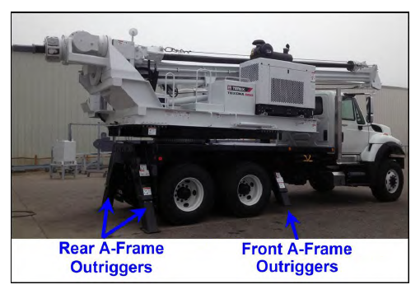
In addition to the above-mentioned criteria the following shall be considered. When a drill rig and its auxiliary equipment is mounted on a truck or trailer chassis, the weight distribution, the axis and tire loading shall be within the limits specified by the vehicle manufacturer.

Consideration shall be given to the effect of the vehicle suspension.
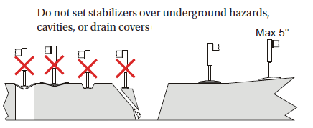

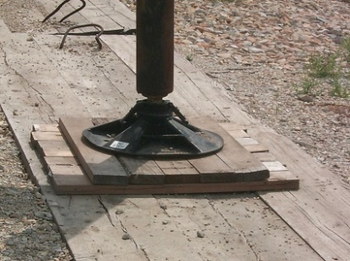
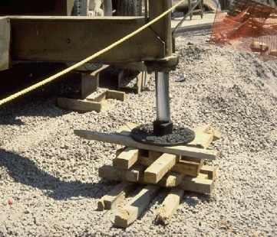
Correct Blocking
Incorrect Blocking

Drill Rig Brakes

Wheel Mounted Brakes General

It shall be possible to slow down, stop and hold at rest self-propelled rigs to ensure safety under all conditions of service, speed, ground conditions and gradients as specified by the manufacturer.

Braking systems may use common components, however in the case of a failure of any single component other than a tire; the braking system shall be capable of bringing the drill rig to a halt in accordance with the performance requirements specified for the secondary braking system.

It shall not be possible from the operator's position to disconnect the brakes from the wheels or tracks.

Where the operation of the service braking system depends on accumulated hydraulic or pneumatic energy and in case the power source becomes inoperative, the system shall be capable of sustaining at least five consecutive applications of the brakes. On the fifth application the brake performance snail not be less than that specified for the secondary braking system.

Where braking systems use an energy reservoir, a pressure gauge shall be located in the driver's field of vision. The minimum pressure required shall be marked on the pressure gauge. Alternatively, a warning device may be provided.

A drill rig, which has any type of remote control for moving, shall be so designed that in case the driver should lose control for any reason, the machine shall stop automatically.

For truck, tractor and trailer mounted drill rigs the relevant road traffic regulations regarding the vehicle brakes apply.

General Braking Requirements for Wheel Mounted Drill Rigs

Wheel mounted drill rigs shall be equipped with:

- A service braking system
- A secondary braking system
- A parking braking system

Pneumatic and hydraulic braking systems shall be designed as dual circuit systems such that at least two wheels on opposite sides of the vehicle are braked in the event of a leak.

Provisions for examining brake wear and brake fluid level in any reservoir shall be made.

Service Braking System for Wheel Mounted Drill Rigs

The service braking system shall give a braking force, in N, equivalent to not less than 35% of the maximum drill rig mass.

In addition to this requirement, the service brake system shall be capable of retarding the drill rig with at least 1 m/s² on the maximum permitted gradient as specified by the manufacturer.

For drill rigs with hydrostatic transmission, service braking action may be performed by means of the hydrostatic transmission if the performance requirements given above are fulfilled.

The service brake shall be resistant to fade due to heat

Secondary Braking System for Wheel Mounted Drill Rigs

A secondary braking system shall be provided to stop the drill rig in any condition of service, speed, ground and gradient as specified by the manufacturer, in the event of any failure in the service braking system.

In addition to this requirement, the secondary brake system shall be capable of retarding the drill rig with at least 1 m/s² on the maximum permitted gradient as specified by the manufacturer. To achieve this brake force, the parking brake may be used in addition.

For drill rigs with a hydrostatic service brake, the secondary braking system shall also achieve independently the braking performance specified in the service brake.

Inspections and Maintenance – Highway Travel

It is important to ensure vehicles are road worthy before using them on public roadways or project sites. Federal, state, and local laws require that vehicles be properly maintained and safe to operate upon our highways. It is the responsibility of the owner or operator to ensure that:

- All drivers are properly licensed for the equipment that they are to be driving and that they are trained in safe driving procedures.
- Equipment is inspected prior to being moved and any deficiencies corrected prior to moving the equipment.
- Complete annual inspections of vehicles are performed.

Regulations require that no motor vehicle be driven unless the driver has satisfied themselves that the following parts and accessories are in good working order, nor will any driver fail to use or make use of such parts and accessories when and as needed:

- Service brakes, including trailer brake connections
- Parking (hand) brake
- Steering mechanism
- Lighting devices and reflectors
- Tires
- Horn
- Windshield wiper or wipers
- Rear-vision mirror or mirrors
- Coupling devices
- Seat belts

Parking Braking System for Wheel and Crawler Mounted Drill Rigs

A purely mechanical parking braking system for holding machines in a stationary position shall be provided.

The parking braking system shall be able to hold the drilling on the steepest slope it can operate on, up to a maximum of 20°, according to the manufacturer’s specification with a safety factor of 1.2.

Service Braking Systems on Crawler Mounted Drill Rigs

Crawler drill rigs shall have either a service and secondary braking system, or two service breaks, one on each track. These shall be controlled individually e.g. by two separate control systems, one on each track. The braking system may be combined with the steering system.

One of the two fully independent braking systems is accepted as the secondary braking system in case of failure of the other brake.

The parking brake may be the same brake as the service brake if it is mechanically spring loaded for automatic braking action in case of loss of power supply.

Braking Systems for "Skid Steer" Wheel Mounted Drill Rigs

For skid steer chassis the same rules as for crawler mounted drill rigs shall apply. Braking action shall be possible on all wheels.

Protection Against Moving Parts

General

The moving parts of a drill rig shall be designed, built and laid out to avoid hazards.

Transmission Parts

Rotating transmission parts such as drive shafts, couplings, belt drives, which are within reach of personnel, shall be provided with guards to prevent contact. Guards shall be of robust construction and securely held in place. Fixed guards shall be used when access is rarely necessary and be held in position either by welding or by mounting them in such a way that they can be opened or removed only with the aid of tools or keys.

When frequent access is required for service or maintenance purposes, moveable guards may be fitted. They shall fulfill the following requirements:

- Whenever possible they shall remain fixed to the machine when open.
- They shall be fitted with a system supporting them in the open position.

Compartments containing internal combustion engines shall be lockable. Movable covers, preventing access to such compartments need to have locking devices to prevent unauthorized access.

Drill Rigs with Rotating Superstructure

The danger zone of the drill rig shall be a restricted access area when drilling and turning the superstructure of the drill rig.

The drill rig shall be provided with warning signs located on the counterweights, or most rearward part of the machine.

Electric Power Installation

An earth fault protection system shall be provided for electrically powered drill rigs.

Battery Installation

The batteries shall be provided with lifting points and be firmly attached to their location. There shall be no risk of electrolyte splashing persons and surrounding equipment. The terminals shall be protected from contact, and an isolator switch shall be fitted in the circuit.

Batteries and/or battery locations shall be designed or covered so that there is no risk to the operator caused by battery electrolyte or vapors even in the event of overturning of the drill rig.

Hydraulic Systems

Hydraulic cylinders used for erection and lifting shall be fitted with load sustaining devices mounted on the cylinder and shall be self-bleeding or fitted with an air bleed point at the highest point.

Flexible hydraulic hoses intended for pressures higher than 15 MPa shall be fitted with swaged fittings.

Hydraulic hoses and pipes shall be separated from electric power wiring and be guarded against hot surfaces and sharp edges.

Pipes and hoses which must be disconnected in operation shall be fitted with self-sealing couplings with built-in check valves. Couplings shall be marked to ensure correct reconnection.
The tanks for hydraulic fluid shall be fitted with level indicators. The filling point of the tank shall be so designed that overflow is prevented when working on any gradient for which the drill rig is designed.

A temperature gauge or a monitor, which gives a warning signal if the allowed temperature is exceeded, shall be provided.

Draw-Works, Winches and Ropes

General

Winches, ropes and sheaves for lifting which are integral parts of the drill rig.

Such systems are:

- Systems running drill rods, chisels, Kelly bars, continuous flight auger, jet grout stems, hammer grabs and other impact tools, by free fall, controlled free fall or powered lowering.
- Systems running drill rods, casings, tools and other accessories in and out of the bore hole.
- Cable feed systems.
- Any other system using winches, ropes and sheaves for any purpose other than lifting goods and personnel.

Safety Requirements

Rope safety factors:

- For running ropes in the normal operating case: 3.5 to 1
- For pendant ropes: 5 to 1

All pulley assemblies shall be provided with devices preventing the rope from disengaging.

There shall always remain at least three wraps of rope on the winch drum. The rope fastening on the drum, shall be such that the fastening strength is at least 70% of the maximum allowed rope load.

The maximum line pull on the first rope layer of the draw-works/winch shall be indicated on the data plate of the winch.

Draw works and winches shall be equipped with:

- A service brake system
- A holding break system

The holding break systems shall act automatically and prevent an unintentional running back of the load if the winch control levers are not actuated or in the case of failure of the energy supply.

Both brake systems shall each hold a minimum of 1.3 times maximum allowed line pull. The service brake shall enable the operator to retard and stop a descending load smoothly.

If the service brake is coupled to the winch or draw-work by means of a disengage-able clutch, a device shall be installed; which is visible to the operator and indicates whether the clutch is engaged or not.

If an electrical eddy-current brake or a fluid fly-wheel brake is fitted as the service brake, all information necessary for the operation, for example rotational speed, temperature, water flow rate, operating voltage, shall be indicated within the view of the winch operator.

Winches or draw-works having an influence on stability shall have a measuring system indicating the actual line pull of the rope or the hook load. A capacity table visible to the operator shall show the allowed line pull.

Draw-works or drill mast winches shall have a limiting device stopping the lifting movement by influencing the winch control, before the mechanical end position is reached. For winches with a capacity equal to or less than 20 kN a mechanical limit stopping device without influence on the winch control is sufficient.

Activation of the free-fall function of the winch shall only be possible by actuation of two independent controls simultaneously. Both controls shall be of the hold-to-run type.

When a winch is designed for several functions, including a free fall function, a key operated control shall be additionally fitted, which allows the free fall function to be operated.

Inspection

A competent person must conduct a documented visual wire rope inspection prior to each shift the equipment is used. The inspection must consist of observation of wire ropes (running and standing) that are likely to be in use during the shift for apparent deficiencies such as significant distortion of the wire rope structure such as kinking, crushing, unstranding, birdcaging, signs of core failure or steel core protrusion between the outer strands, significant corrosion, electric arc damage (from a source other than power lines) or heat damage, improperly applied end connection, or significantly corroded, cracked, bent, or worn end connections (such as from severe service).

In running wire ropes: Six randomly distributed broken wires in one rope lay or three broken wires in one strand in one rope lay. A rope lay is the length along the rope in which one strand makes a complete revolution around the rope.

In rotation resistant ropes: Two randomly distributed broken wires in six rope diameters or four randomly distributed broken wires in 30 rope diameters.

In pendants or standing wire ropes: More than two broken wires in one rope lay located in rope beyond end connections and/or more than one broken wire in a rope lay located at an end connection.

If the defects noted are found, then the wire rope must be repaired or replaced as required by the manufacturer of the foundation drill rig.

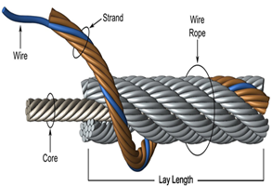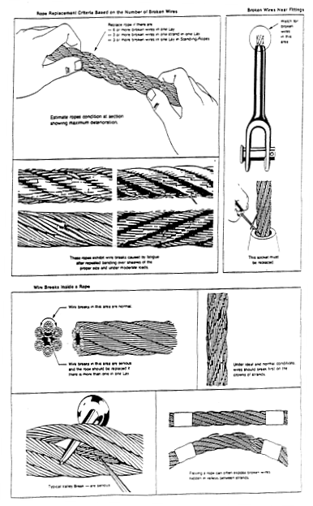

Warning Devices

Warning devices such as signals, etc. shall be unambiguous and easily perceived. The operator shall have the facility to check the operation of all essential warning devices at all times.

There shall be a manually operated, audible alert signal to warn personnel in the working area of impending danger. It shall be possible to operate the audible warning for each driving or operating position including (if applicable) a remotely situated monitoring position. There shall also be an automatic, audible or visual warning signal given when reversing.

Set-up and Operation

Location

After consulting with the Owner / General Contractor (GC), the Deep Foundation Contractor (DFC) should ensure the location selected for the equipment set-up is suitable, considering whether:

- the area is accessible, and any slopes are within the operating capacity of the equipment;
- the surface is firm, able to support the weight of the operating foundation drilling equipment;
- the area is clear from obstructions and excavations;
- the equipment can be operated without encroaching the ‘no-go zone’ areas near overhead powerlines;
- underground services or buried structures are identified;
- an effective operational safety zone can be established;
- any public protection needs to be implemented.

Locating Underground Utilities

1. The Deep Foundation Contractor (DFC) must be aware of all services that may affect the work or that maybe located in the work zone and have a valid copy of all locates.

2. Locates shall be obtained prior to commencement of drilling by contacting the utility locate service (contact information varies) and additionally any utility owner that is not associated with a one call system. Locates may only valid for a specified amount of time from the date of issue. Always refer to the special instructions section of the utility locates for further instruction from the utility owner.

3. Proof that locates were completed are required on site for the duration of the project.

4. Clearly marked stakes, flags or paint will indicate the location of various underground utilities.

5. In the case of any uncertainty as to specific location of underground utilities, excavation, drilling of piles is not to commence until the service is exposed or located by hand (shoveling) or other means (e.g. hydrovac).

6. The underground utility must be located by hand excavation and visually inspected if located close to the work area. If the located utility stakes or paint is within a distance equal to the stake-out tolerance (typically 1m) then hand-excavated test pits shall be required prior to commencement of deep foundation work.

7. Services that are known to be close to the deep foundation elements may require some type of special protection. Contact the appropriate utility owner to agree on such protective measures.

8. If unanticipated underground utilities are encountered, work shall cease at that location until the utility and its owner has been identified and it has been deemed safe to continue.

Equipment

Ensure all foundation drill rigs and auxiliary equipment are in a mechanically sound condition and have:

- comprehensive operator’s instructions or the manufacturer’s operation manuals;
- correctly positioned and legible warning/safety signs or stickers;
- all required safety equipment fitted;
- an adequate supply of packing for any stabilizer base plates;
- current risk assessment;
- up to date equipment maintenance logbooks;
- required registration or DOT/interstate equivalent.

Loading – Unloading Equipment

When loading or unloading a drill rig on a trailer or a truck, follow these precautions:

- Select an area of level ground for loading and unloading.
- Have a spotter guide the driver on/off the trailer or truck.
- Before using a ramp, verify the brakes of the drill rig are in working order
- Ensure that any ramps used are designed for this purpose and provide a sturdy and solid enough base to bear the weight of the drill rig with carrier including tooling.
- Verify that when the drill rig is on the trailer, the weight of the drill rig, carrier and tools are centered on the centerline of the trailer. In addition, some of the trailer load should be transferred to the hitch of the tow vehicle. Refer to the trailer recommendations for weight distribution provided by the manufacturer.
- Verify the drill rig is secured to the towing vehicle with ties, chains, or load binders that can handle the required weight.

Assembly and Disassembly of Rigs
The Deep Foundation Contractor (DFC) should develop or have access to detailed procedures for the assembly and disassembly of the foundation drill rig. These procedures should be based on:

- the manufacturer’s recommendations
- controlling the risks of working at height
- working around powered mobile plant
- ensuring the foundation drill rig structural stability during the process
- verification that the equipment is correctly assembled

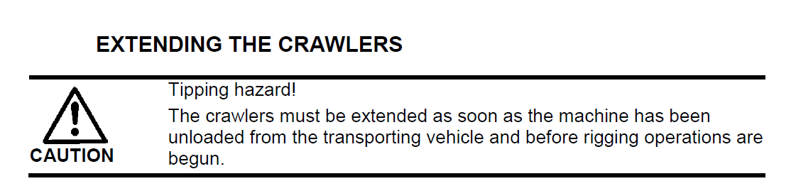

A JHA (Job Hazard Analysis) must be developed before work starts and followed during the assembly or disassembly process.

Employees must be appropriately trained and instructed in the assembly or disassembly procedures for the specific foundation drill rig and supervised to ensure they work safely.

Exclusion Zones

Establish an exclusion zone around the drilling operations to keep activities separate from other onsite construction activities and to separate foundation drilling equipment from people.

Only those involved in the drilling operations should enter the exclusion zone. Precautions should be in place to prevent unauthorized persons or equipment from accessing the safety zone area.

Exclusion zone zones should be clearly marked by a physical barrier and signage. If a physical barrier is not reasonably practical, the operational safety zone boundary should be indicated with appropriate signage warning people to keep out.

An exclusion zone should be large enough to provide adequate clearance distances to prevent equipment from impacting other site works or activities. When establishing the exclusion zone, consider the risks from the work including:

- the working radius of the foundation drill rig and auxiliary equipment
- separation of hazards from adjacent activities such as excavations, site traffic thoroughfares, pedestrian access walkways and other construction activities (e.g. demolition)

The exclusion zone must be included as one of the controls for working in the vicinity of a foundation drill rig in the site-specific safety plan.

Powerlines and Electrical Equipment

Overhead Powerline Safe Working Clearance:

Note: Dedicated Drilling Rigs are not considered to be nor defined as “Cranes” in the US and Canada. However, in the following resources, the reader will note that there are numerous references to mobile cranes and not dedicated drill rigs per se. As a best practices precaution, the safe working distances and warning procedures noted for mobile cranes per OSHA CFR 1926.1409, must be applied to the use of dedicated drilling rigs – of any type.

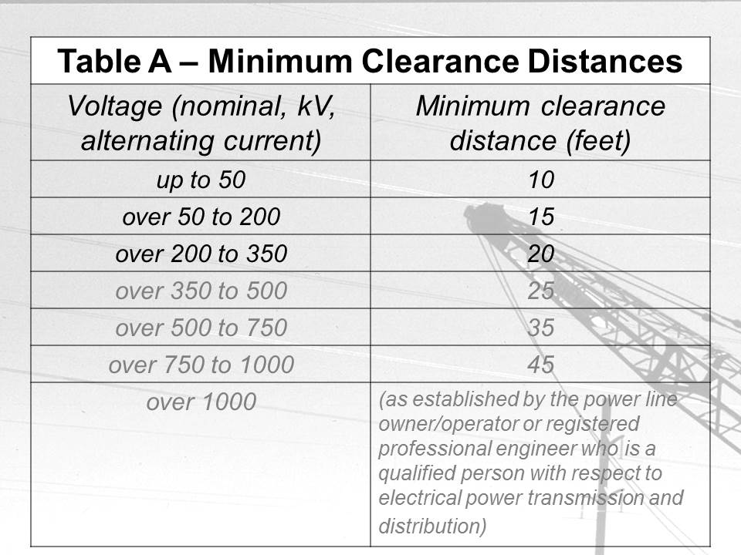
When operating a foundation drill rig near overhead powerlines the site-specific safety plan must detail the safe working procedures, and the requirements of the minimum clearance distances to be observed.

No part of a foundation drilling rig or its load should come closer than 10 feet (3.05 metres) of an energized powerline. As the voltage increases, the safe clearance distance also increases – see Table “A” for reference.

Ensure excavation works or working platform construction does not alter ground levels or reduce safe clearances under powerlines.

Equipment, Inspection and Maintenance

General
Regular inspections and preventative maintenance of a foundation drill rig and auxiliary equipment are essential for the safe and efficient operation, and to ensure mechanical integrity of all components. Failure of key components may cause an incident and possible collapse of the rig or its parts.

A maintenance and inspection program should consider the equipment’s working environment and usage. It should be based on the manufacturer’s recommendations or designed by a competent person to either achieve the same safety outcomes or compliance with the relevant construction safety standards.

The maintenance program should include:

- pre-operational inspections and tests;
- routine inspection, servicing and maintenance at specified intervals;
- periodic/annual inspections;
- major inspections at specified intervals;
- all items listed in the manufacturer’s manual.

The following should be recorded in the plant’s service book and in more detail in the maintenance records:

- inspections and maintenance;
- defects found, and repairs undertaken;
- structural alterations.

Note: A copy of the manufacturer’s manuals should be kept in the foundation drill rig, or onsite in a safe area. Contractors should ensure service records and maintenance manuals are maintained, kept in a safe and accessible place.

Pre-operational Inspections

A pre-operational inspection of all relevant items indicated in the operations and/or manufacturer’s manual should be done prior to the start of each shift and include inspecting and/or testing for:

- equipment access
- clear visibility from the operator’s position
- operating and emergency controls
- brakes
- safety switches and interlocks, including limiting and indicating devices
- visual inspection of the structure, including pipelines and connections (where applicable)
- wire ropes to ensure they are on the drum, correctly reeved on the sheave and in good condition.

Routine Maintenance

All foundation drill rigs should be inspected and maintained by a competent person at intervals specified in the maintenance program. The competent person should ensure the maintenance is done to the manufacturer’s requirements and the specified items are inspected and/or tested. This includes:

- emergency devices
- operator controls
- components associated with lifting (e.g. wire ropes and sheaves)
- interlocks and travel limiting devices
- access to the machine for operation and maintenance
- critical components (e.g. brakes, gears, fasteners, pins and shafts
- track wear
- areas affected by corrosion, damage, wear or abrasion
- drill rig and its components after transportation (e.g. return from site)
- metal fatigue in critical wear or stress points
- additional items required for inspection by the manufacturer

The results of the inspection must be entered in a logbook and kept with the foundation drill rig. All safety-related faults must be reported and corrected before the piling rig is used and recorded at an appropriate time.

Annual Inspections

A competent person should inspect each foundation drill rig at least every 365 days. The competent person’s inspection should review the routine maintenance reports and verify any identified defects and faults have been repaired. The competent person should inspect all high stress areas, critical mechanical and structural components, including visual, selected strip-down and other testing (e.g. nondestructive testing) as required or necessary to make an accurate assessment of the equipment’s condition.

To ensure the foundation drill rig is safe for continued operation it should be inspected and tested based on the rig’s age, usage and known critical wear areas or components. In the absence of verifiable records of previous maintenance, inspection repairs or modifications, the foundation drilling rig should be assessed to its suitability from continued service.

Competent Person for Inspections

A competent person should have the knowledge, skills and the experience necessary to accurately assess the condition of the foundation drilling equipment and components. Different skill sets may be required depending on the inspection criteria or the components being inspected. The competent person could be an independent consultant, the rig manufacturer or a person employed by the owner of the rig.

Repairs
Repairs made to any equipment should be done according to the manufacturer’s maintenance and repair manuals or detailed instructions from a competent person. All repairs and any replacement of components should:

- be carried out by a competent person;
- use Original Equipment Manufacturer (OEM) parts or those that are compatible with OEM and with at least the same specifications;
- be recorded in the service book and detailed in the maintenance records.

Welding

Welding of load bearing components should be done by a suitably qualified welder and recorded in the service book and detailed in the maintenance records.

Note: For equipment with on board computer systems - it is essential that the manufacturer’s procedures with respect to battery disconnection be strictly followed. If not followed, severe electronic damage can occur at the first strike of an arc.

Equipment Modifications

The modifier of the equipment may take on legal obligations of designer, manufacturer and supplier when they alter the equipment; including doing a risk assessment and providing safe use information.

Modifications to road carrier vehicles need to comply with the requirements of the Department of Transportation (DOT). Engineering calculations may need to be done to verify the modifications comply with relevant technical standards and associated strength and operational requirements. Modifications with the potential to affect safe operation of equipment should be approved in writing by the manufacturer or a qualified mechanical engineer. Engineering calculations and approvals should be kept for the life of the equipment.

Maintenance Records
Maintenance records should:

- clearly describe the work undertaken and parts replaced
- record the date of inspection and maintenance
- note who did the work and any recommendations for the preventative maintenance program register
- be signed by the person carrying out the work
- be kept for the life of the equipment
- be readily available

Drilling Operations

General

- Ensure that all personnel remain clear of the swing radius of all equipment and that workers around heavy equipment are identified by the operator. Be aware of and avoid the operator's blind spots.

- No equipment or tools may enter the safe limits of approach for all overhead wires as per the Safety Regulations for Construction Projects. Always assume that every electrical line is energized, until proven otherwise.

- An effective means of communication between the workers shall be established and maintained. The drill operator and front-end worker shall agree on the type of communication to be used prior to starting work. Hand signals must be used when verbal communication is not effective. All workers shall be familiar with machine operation hand signals; however, the operator shall accept signals only from the designated signal person except for an emergency stop signal, which may be given by any worker.

- When open-hole drilling is being performed, soil conditions shall be carefully observed during drilling of each hole. If loose or caving material is observed which may endanger the surrounding work area, measures such as the use of sectional casings/liners and/or drilling slurry shall be introduced. These measures will remain in place until the holes have been backfilled above the loose or caving material.

- Avoid approaching the hole unnecessarily; maintain a distance of at least 1.8m or 6 feet from any open hole. Added precautions should be observed during work that may disturb the ground surface such as casing/liner placement and removal.

- Before placing concrete, check to see that no one is inside the caisson or an adjacent caisson. Discuss the soil conditions with the project engineer if any concern regarding the safe working distance between holes under construction.

- When replacing worn teeth on an auger or other drilling tool attachment use safety glasses/goggles and a face shield and the proper installation tools. Avoid metal to metal contact by using polymer sledge hammers or dead blow hammers.

- Never clean an auger pinhole with fingers. Use a wood dowel or piece of reinforcing steel that will keep fingers clear of being pinched.

- After any suspension of drilling always check that a drilled hole is clear prior to resuming operations.

Auxiliary Winch for Lifting

Most drill rigs have an auxiliary or service winch to assist in the drilling operation. It is used to handle small reinforcing cages, tooling, and some casing, much like a “crane” might do. That said, drill rigs differ from a crane in the following ways:

- Drill rig design does not provide for mast tip positioning which is critical in crane use. In many cases, mast tipping is limited to no more than 5 degrees from vertical.

- Even at a 5-degree tilt from vertical, a drill rig mast is far closer to “vertical” than any typical crane boom will go, thus further limiting its working radius of a suspended load.

- Hoisting capacity of auxiliary winch is limited due to winch design and inability to multi-part the line. User must always follow the manufacturer’s recommended capacities, mast angle, or load radius.

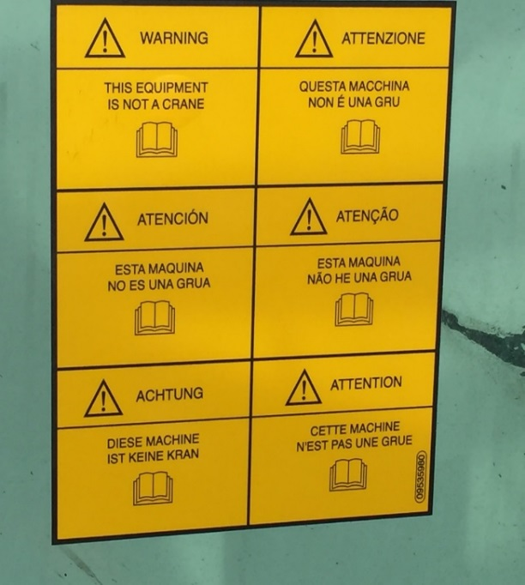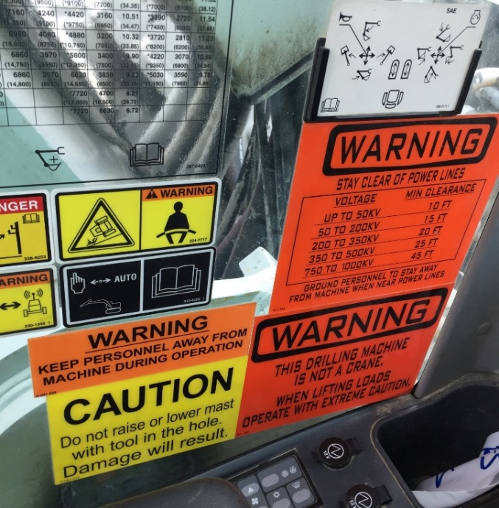

Example of manufacturer’s restrictions when using the auxiliary winch

CFA Drilling

When drilling in CFA (Continuous Flight Auger) mode, the auger flights may fill with material, causing a change in the drill rig’s center of gravity. An unstable condition may result if the auger is not kept clean.

Example of manufacturer’s warning regarding continuous flight auger

Acknowledgments:

The authors wish to acknowledge and thank the following organizations for their support in the development of this manual:

- ADSC: International Association of Foundation Drilling
- Bauer Foundations Australia Pty Ltd
- Bauer Maschinen GmbH
- Bayshore Systems
- BRC Piling & Foundations Pty Ltd
- Casagrande S.p.A.
- Construction, Forestry, Mining & Energy Union (CFMEU)
- CZM Foundation Equipment
- Frankipile Australia Pty Ltd
- Geotech Pty Ltd
- Liebherr-Werk Nenzing GmbH
- Master Builders Association of Victoria (MBAV)
- NAIT: Northern Alberta Institute of Technology
- NCCCO: National Commission for the Certification of Crane Operators
- Ontario Association of Foundation Specialists
- OSHA - Occupational Safety and Health Administration
- Piling and Foundation Specialists Federation (PFSF)
- Piling Contractors Pty Ltd
- Soilmec S. p. A.
- Terex Utilities
- Vibro-pile (Aust.) Pty Ltd
- Victorian Construction Safety Alliance (VCSA)
- Wagstaff Piling Pty Ltd
- Watson Drill Rigs
- WorkSafe Victoria

Appendices:

Resource Material Available Without Cost:

The following resources are available for free using the Internet links provided.

Overhead Powerline Safe Working Clearance:

http://www.hydroone.com/SiteCollectionDocuments/Safety/ZapZonePamphlet.pdf
https://www.workzonesafety.org/files/documents/news_events/wz_conference_2002/avoiding_contact.pdf
http://www.penticton.ca/assets/Departments/Documents/ElecticalSafety-HighVoltage.pdf
https://www.osha.gov/pls/oshaweb/owadisp.show_document?p_table=STANDARDS&p_id=19

Note: Dedicated Drilling Rigs are not considered to be nor defined as “Cranes” in the US and Canada. However, in the following resources, the reader will note that are numerous references to mobile cranes and not dedicated drill rigs per se. As a best practices precaution, the safe working distances and warning procedures noted for mobile cranes, must be applied to the use of dedicated drilling rigs – of any type.

Underground Utility Location:

http://albertaonecall.com/learning-centre/color-code-explanation/
http://call811.com/best-practices/best-practices-guide/uniform-color-code
http://www.clickbeforeyoudig.com/
http://call811.com/811-your-state

Rotary Foundation Drilling Rig Safety:

http://www.hse.gov.uk/foi/internalops/og/og-00055.htm
http://www.oafs.org/downloads/SafetyProcedures.pdf
https://pilingfederation.org.au/

Construction Safety Regulations:

OSHA – Occupational Safety & Health Administration
https://www.osha.gov/pls/oshaweb/owasrch.search_form?p_doc_type=STANDARDS&p_toc_level=1&p_keyvalue=Construction

US Army Corps of Engineers Safety and Health Requirements Manual
http://www.usace.army.mil/Safety-and-Occupational-Health/EM-385-1-1-2008-Being-Revised/

The Federation of Piling Specialists
http://www.fps.org.uk/

The National Institute for Occupational Safety and Health (NIOSH)
https://www.cdc.gov/niosh/construction/

Canadian Centre for Occupational Health and Safety – Links to Provincial Requirements
http://www.ccohs.ca/oshanswers/information/govt.html

Canada National Occupational Health and Safety Regulations
http://www.laws-lois.justice.gc.ca/eng/regulations/SOR-86-304/index.html

Education:

Northern Alberta Institute of Technology (NAIT) Foundation Drill Rig Operator Program
http://www.nait.ca/program_home_103029.htm

Rigging Information:

Crosby Group
http://www.thecrosbygroup.com/catalog/rigging-information/

National Commission for the Certification of Crane Operators (NCCCO) Reference Manuals
http://nccco.org/nccco/safety-information-research-education-network

Resource Material Available for Purchase:

The following resources are available for purchase using the Internet links provided.

European Standards:

EN 16228-1 Drilling and Foundation Equipment - Safety - Part 1 – Part 7
https://www.en-standard.eu/csn-en-16228-1-drilling-and-foundation-equipment-safety-part-1-common-requirements/?gclid=EAIaIQobChMIyMLW4Mbe1QIVUoGzCh1SNAkNEAAYASAAEgKMH_D_BwE

American Society of Safety Professionals (ASSP):

ANSI/ASSE A10.23-2014 - Safety Requirements for the Installation of Drilled Shafts
http://www.asse.org/ansi/asse-a10-23-2014-safety-requirements-for-the-installation-of-drilled-shafts/

ADSC: The International Association of Foundation Drilling:
http://foundationdrillingmagazine.com/tlc17/index.html

- Down-Hole Entry Manual: Recommended Procedures for the Entry of Drilled Shaft Excavations
- Drilling Operators Machine Safety Guide
- Recommended Procedures for Fall Protection in Shaft Excavation Operations
- Anchor and Micropile Installation safety Guide

