**Southeast Chapter Safety Summit and Braves Game in Atlanta, GA**

**Update – OSHA will have a representative at the Safety Summit**

**This event is limited to 80 people, please don’t delay in registering ASAP. – Thanks to all the early registrants and sponsors!**

[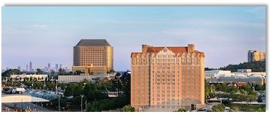](https://www.marriott.com/search/findHotels.mi)

**Date: Tuesday June 18, 2019**

## [Sheraton Suites Galleria-Atlanta](https://www.marriott.com/search/hotelQuickView.mi?propertyId=ATLGS&brandCode=SI&marshaCode=ATLGS)

**2844 Cobb Parkway SE Atlanta, Georgia 30339**

**T (770) 916 3180**

[**Book your group rate for ADSC Southeast Chapter Safety**](https://www.marriott.com/events/start.mi?id=1552663530061&key=GRP)

Schedule: 1pm – Registration and Networking

                 1:30pm – Announcements

                 2pm – Safety Panel Discussion moderated by Rick Marshall

                 4pm – Conclusion; walk to the Braves game

Please grab your safety director and join us for an open discussion about safety,

with a panel of safety experts representing all aspects of our industry.

We will field questions and discuss safety topics and situations that are important to all of our members.