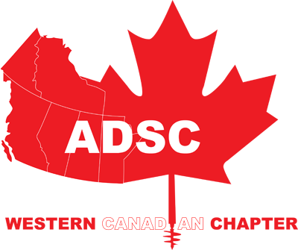 | ADSC Western Canadian Chapter AGM  Victoria, BC  Wednesday May 8th to Thursday May 9th ADSC Western Canadian Chapter AG
Location: Delta Hotels Victoria Ocean Pointe Resort
100 Harbour Road, Victoria

Time: 7:30am-4:30pm ( elections will be held from 4:00PM-4:30PM)

Conference Registration Fees In Canadian Dollars

Western Canadian Chapter Members $325.00
Non Members $375.00

Registration fees do not include your hotel accommodations or airfare.

Registration Includes:
- Welcome Reception
- Registration gift
- Full breakfast and lunch Wednesday- Please inform Brittany Sharp of any allergies or food restrictions by April.24th 2019
- AM & PM Breaks
- Presentations & Keynote speaker

Cancellation Policy:
A 50% refund is allowed on cancellations received by Brittany Sharp on or before April.24 2019, after this date no refunds.

Attendee Information
Name: |  | Company:
Email:
Name: |  | Company:
Email:
Name: |  | Company:
Email:
Name: |  | Company:
Email:
Name: |  | Company:
Email:

Sponsorship Opportunities

All Sponsorship must be in by April 24th 2019 in order for recognition in agenda and signage

Gold Sponsor: $750.00
- Your company name appears in the On-Site Agenda.
- A sign listing Gold Sponsors will be displayed throughout the meeting.

Platinum Sponsor: $1500.00
- Your company name appears in the On-Site Agenda.
- A sign listing the Platinum Sponsors will be displayed throughout the meeting.

Diamond Sponsor: $2000.00

- Your company name appears in the On-Site Agenda.
- A sign listing Diamond Sponsors will be displayed throughout the meeting.
- Diamond Sponsors will be exclusively recognized at the complimentary cocktail reception
- Registration for one person include
- 15 Minute Presentation slot

Table Top Opportunities

Tabletop exhibit space will be available at $675 for Western Canadian Chapter members. Exhibit space is limited and is on a first come first serve basis. One registration is included with a tabletop exhibit.

To ship any materials prior to event please make all arrangements through conference services at the hotel.

Payment

Name On Card: |  | Card Type:
Card #: |  | Expiry:
Postal Code: |  | Security Code:
Total Amount:

If paying by Cheque please make payable to Western Canadian Chaper- ADSC (Send to Rob Beard, C/O Northstar Sharp’s Foundation Specialists, 1511 Sparrow Drive, Nisku, AB, T9E 8H9)

Please send filled out registration form back to Brittany.m.sharp@gmail.com

