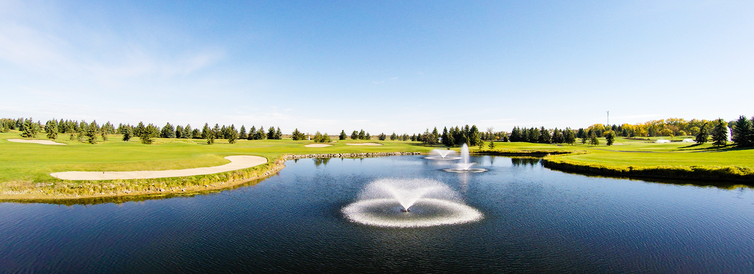

**2017 Fall Classic**

Join us in the Fall Classic Golf Tournament at Edmonton Petroleum Golf & Country Club located just 5 minutes off the west Anthony Henday Rain or shine, shotgun start at 8:30 am. Breakfast sandwich and check in 8:00am. Pick up from hotel 7:30am Sharp and drop off after lunch and golf.

**(Registration form and payment details at the back of package)**

**Registration Includes:**

* Tee Gift
* Power cart and 18 holes of golf
* Breakfast Sandwich and Coffee
* Two Drink Tickets
* Delicious late afternoon lunch
* Prizes
* Guaranteed good time!

**Registration Fee:**

Members: $240.00

Non Members: $250.00

**Please email this form to Brittany.m.sharp@gmail.com.**

**If club rental if required ($50.00 per set)**



**Club rentals:**

Club rental ($50.00 per set)

NEED TO KNOW BY AUGUST.30th OR CLUB RENTALS WILL NOT BE AVAILABLE

Men’s Right Men’s Left

Women’s Right Women’s Left

**Sponsorship Opportunities:**

**Please send logo with registration for marketing purposes**

|  |  |  |  |
| --- | --- | --- | --- |
|  | Men’s Closest to the Pin ($250.00) |  | Women’s Closest to the Pin ($250.00) |
|  | Men’s Longest Putt ($250.00) |  | Women’s Longest Putt ($250.00) |
|  | Men’s Longest Drive ($250.00) |  | Women’s Longest Drive ($250.00) |
|  | Winning Team ($500.00) |  | Hole Sponsor ($250.00) |

**Player’s Information:**

|  |  |  |  |
| --- | --- | --- | --- |
| **Name:** | Click here to enter text. | **Name:** | Click here to enter text. |
| **Name:** | Click here to enter text. | **Name:** | Click here to enter text. |
| **Company Name:** | Click here to enter text. | | |
| **Address:** | Click here to enter text. | | |
| **Phone Number:** | Click here to enter text. | | |
| **Email:** | Click here to enter text. | | |

***Dress Code***

* Collared shirts (Ladies must have a collar or sleeves)
* Slacks
* Golf shorts (tailored and approximately mid-thigh)
* ***Not Permitted on course - short shorts, cargo shorts or pants and jeans or denim***
* Denim/blue jeans are permitted in the Spike Bar and patio, but not allowed in the dining room, driving range or on the course.

**Payment Information**

**Credit Card Information:**

|  |  |
| --- | --- |
| **Name on Card:** | Click here to enter text. |
| **Card #:** | Click here to enter text. |
| **Card Type:** | Click here to enter text. |
| **Expiration Date:** | Click here to enter text. |
| **Security Code:** | Click here to enter text. |
| **Postal Code that corresponds with card:** | Click here to enter text. |
| **Total Amount** |  |

**If paying by Cheque please make payable to Western Canadian Chaper- ADSC (Send to Brittany Sharp, C/O Northstar Sharp’s Foundation Specialists, 1511 Sparrow Drive, Nisku, AB, T9E 8H9)**

**Cancellation Policy:**

A 50% refund is allowed on cancellations received in writing to Brittany Sharp on or before **Aug.30th, 2017**.

**Substitution of Golfer:**

All substitution requests must be in writing via email to Brittany Sharp, and requested prior to **Sept.6th 2017**

**Please RSVP Registration and or Sponsorship information by email to: brittany.m.sharp@gmail.com by August 30, 2017.**

